**Assessing the Relationship Between Urban Green Spaces and Microclimate Variability in Ibadan City**

**Objectives:**

* To evaluate the spatial distribution of urban green spaces using NDVI analysis.
* To examine the relationship between NDVI and surface temperature trends.
* To assess the impact of green spaces on urban heat regulation and potential climate resilience.

**Research Methodology**

This remote sensing methodologies for the analysis of spatiotemporal changes in vegetation indices and land surface temperature over a decadal period (2014-2024). The methodological framework encompassed systematic data collection, rigorous preprocessing protocols, and standardized processing techniques for both NDVI and LST analyses (Weng et al., 2004; Voogt & Oke, 2003).

**Study Area**

Ibadan, the capital of Oyo State, Nigeria, is located between latitude 7°20′N and 7°40′N and longitude 3°50′E and 4°10′E, covering a vast land area with diverse topography. The city lies at an elevation ranging between 150 and 275 meters above sea level, with undulating hills and valleys that influence drainage and settlement patterns. Ibadan comprises five urban Local Government Areas (LGAs): Ibadan North, Ibadan North-East, Ibadan North-West, Ibadan South-East, and Ibadan South-West, which collectively form the core metropolitan region. The city experiences a tropical wet-and-dry climate (Aw) under the Köppen classification, characterized by distinct rainy and dry seasons. The rainy season typically lasts from March to October, with peak rainfall occurring between June and September, while the dry season extends from November to February, marked by lower humidity and the influence of the Harmattan winds. Annual rainfall averages between 1,200 mm and 1,400 mm, supporting lush vegetation dominated by a mix of tropical rainforest and derived savanna. Temperatures in Ibadan are generally warm throughout the year, ranging between 21°C and 34°C, with March and April being the hottest months. The metropolitan region, consisting of the five LGAs, is home to a rapidly growing population exceeding 3.5 million residents, making it one of Nigeria's largest urban centers.

Figure 1: Map of the Study Area Showing the Five Local Government Areas of Ibadan

**Software Used**

**Google Earth Engine**

Google Earth Engine (GEE) is a powerful cloud-based geospatial analysis platform that enables the processing of large-scale satellite imagery and spatial datasets. It provides access to a vast repository of remote sensing data and computational resources for efficient analysis. In this study, GEE was used to generate the Normalized Difference Vegetation Index (NDVI) and Land Surface Temperature (LST) for the selected year. NDVI was derived to assess vegetation health and coverage, while LST was extracted to analyze temperature variations across the study area. The cloud computing capability of GEE allowed for fast and accurate processing without the need for extensive local computing resources.

**ArcMap**

ArcMap, a component of Esri’s ArcGIS suite, was used to design and visualize the final map layout. This desktop-based Geographic Information System (GIS) software provides advanced cartographic tools for spatial data representation. It was employed to organize, symbolize, and present the processed NDVI and LST data in a clear and meaningful way. The map layout design included essential elements such as legends, scale bars, and north arrows to enhance readability and interpretation. ArcMap’s spatial analysis and mapping capabilities ensured that the results were effectively communicated for further analysis and decision-making.

**Data Acquisition and Processing**

Landsat 8 OLI/TIRS imagery was systematically acquired and processed following standardized remote sensing protocols to ensure data consistency and reliability. The study covered the period from 2014 to 2024, with imagery carefully selected based on minimal cloud cover and seasonal consistency to enhance temporal comparability. Only images with less than 10% cloud cover were retained to minimize atmospheric distortions and ensure high-quality analysis (Chen et al., 2006). During the data processing phase, significant cloud contamination was detected in the thermal infrared band (Band 10) for the years 2017 and 2021. Since this affected the accuracy of Land Surface Temperature (LST) calculations, data for these years were excluded from the analysis. This exclusion was necessary to maintain data integrity and prevent artificial trends in the temporal sequence. To evaluate annual variations in NDVI and LST, the average of all available cloud-filtered imagery for each year was calculated. This approach ensured that the dataset accurately represented temporal changes while minimizing the impact of cloud cover and data gaps. NDVI and LST values were then derived from processed imagery, providing insights into vegetation health and surface temperature dynamics over the study period.

**Normalized Difference Vegetation Index**

The Normalized Difference Vegetation Index (NDVI) is the most used vegetation index for observe greenery globally. In Remote Sensing, Healthy vegetation is a good absorber in the electromagnetic spectrum. Chlorophyll contains in a greenery highly absorbs Blue (0.4 - 0.5 µm) and Red (0.6 - 0.7 µm) spectrum and reflects Green (0.5 – 0.6 µm) spectrum. Therefore, our eye perceives healthy vegetation as green. Healthy plants having high reflectance in Near Infrared (NIR) between 0.7 to 1.3 µm. This is primarily due to internal structure of plant leaves. High reflectance in NIR and high absorption in Red spectrum, these two bands are used to calculate NDVI. So, following formula gives Normalized Difference Vegetation Index (NDVI).

The NDVI value varies from -1 to 1. Higher the value of NDVI reflects high Near Infrared (NIR), means dense greenery. Generally, we obtain following result:

* NDVI = -1 to 0 represent Water bodies
* NDVI = -0.1 to 0.1 represent Barren rocks, sand, or snow
* NDVI = 0.2 to 0.5 represent Shrubs and grasslands or senescing crops

NDVI = 0.6 to 1.0 represent Dense vegetation or tropical rainforest

------------------------------------------------------------------------------- 1

**Land Surface Temperature Retrieval**

The Land Surface Temperature was estimated using the Landsat imageries acquired in 2014 to 2024 in this study. It simply required applying sets of equations using Google Earth engine. To calculate the LST for Landsat OLI. The DN values were converted to Radiance using the equation below, making use of the rescaling factors provided in the metadata file (USGS, 2016).

----------------------------------------------------------------------------------- 2

Where,

Lλ = TOA Reflectance,

AL = Reflectance additive scaling factor for the band

QCAL = L1 pixel value in DN

Mρ = Band-specific multiplicative rescaling factor from the metadata (RADIANCE MULTI BAND x, where x is the band number).

The spectral Radiance that was gotten from converting DN values was further converted to at-sensor brightness temperature using the equation below (11)

TB = ------------------------------------------------------------------------------------------- 3

Where:

K1 = Band-specific thermal conversion constant from the metadata (K1_CONSTANT_BAND_x, where x is the thermal band number).

K2 = Band-specific thermal conversion constant from the metadata (K2_CONSTANT_BAND_x, where x is the thermal band number).

Lλ = TOA Reflectance

Before one can accurately determine the surface temperature of a location, an accurate knowledge of Surface Emissivity is required. According to Synder, et al., (1998), the emissivity of a surface can be determined as the contribution of the different components that belong to the pixels according to their proportions.

In this study, NDVI threshold method was used to determine surface emissivity as proposed by Sobrino, Jiménez-Muñoz & Paolini (Sobrino et al., 2004). The calculation of NDVI is important because, subsequently, the proportion of vegetation (Pv), which is highly related to the NDVI, and emissivity (ε), which is related to the Pv, must be calculated.

-------------------------------------------------------------------------------- 4

Using the NDVI values obtained, the proportion of vegetation (Pv) is calculated using the equation below;

Pv = --------------------------------------------------------------------- 5

Now that the NDVI and Pv have been calculated, the Surface Emissivity ε can now be determined using the equation below:

------------------------------------------------------------------------ 6

Where:

ε = Surface Emissivity

0.986 = Correction value of the equation

The land surface temperature corrected for spectral emissivity is computed as follows (Artis & Carnahan, 1982):

LST = --------------------------------------------------------------------------- 7

Where:

λ = central band wavelength of emitted radiance (11.45 μm)

ρ = h * c/ σ (1.438*10-2m*K) with: h is the Planck’s constant (6.62* 10-34J*s), c is the velocity of the light (2.998*108 m/s) and σ is the Boltzmann constant (1.38*10-23 J/K)

ε = Surface Emissivity

After the LST has been calculated, to obtain the results in degree Celsius, the value is adjusted by adding the absolute zero (approx. -273.15°C).

LST (0Celsius = LST (Kelvin) – 273.15 -------------------------------------------------------- 8

**Results and Discussion**

**The Normalized Difference Vegetation Index (NDVI)**

NDVI (Normalized Difference Vegetation Index) (Rouse et al., 1974) maps for each year from 2014 to 2024 were analyzed to assess spatial and temporal changes in vegetation cover. The color-coded maps highlight variations in NDVI values, with red (ranging from -0.014 to 0.073) indicating low NDVI (urban areas or barren land), yellow and orange (0.074 to 0.23) representing moderate vegetation, and green (0.21 to 0.48) signifying dense, healthy vegetation (Tucker, 1979). Trends were observed by comparing annual NDVI distributions, identifying regions with significant changes, and correlating them with potential environmental or anthropogenic influences (Pettorelli et al., 2005). Between 2014 and 2017, a significant portion of the region displayed low NDVI values, with most areas falling in the range of 0.031 to 0.13. This suggests urban expansion (Grimm et al., 2008), deforestation (Hansen et al., 2013), or land degradation (Bai et al., 2008). A gradual increase in NDVI values was observed from 2018 to 2021, with more areas transitioning from low (0.03-0.12) to moderate vegetation (0.13-0.27). This change may be attributed to afforestation initiatives (Chazdon, 2008), improved agricultural practices (Pretty, 2008), or seasonal variations favoring vegetation growth. Notably, from 2022 to 2024, the NDVI maps show a substantial increase in green areas, with NDVI values ranging from 0.23 to 0.48. This suggests successful land restoration (Aronson & Alexander, 2013), improved environmental policies (Jordan & Lenschow, 2010), or favorable climatic conditions. The reduction in red zones indicates a possible decline in urban expansion or better land-use management (Seto et al., 2011).

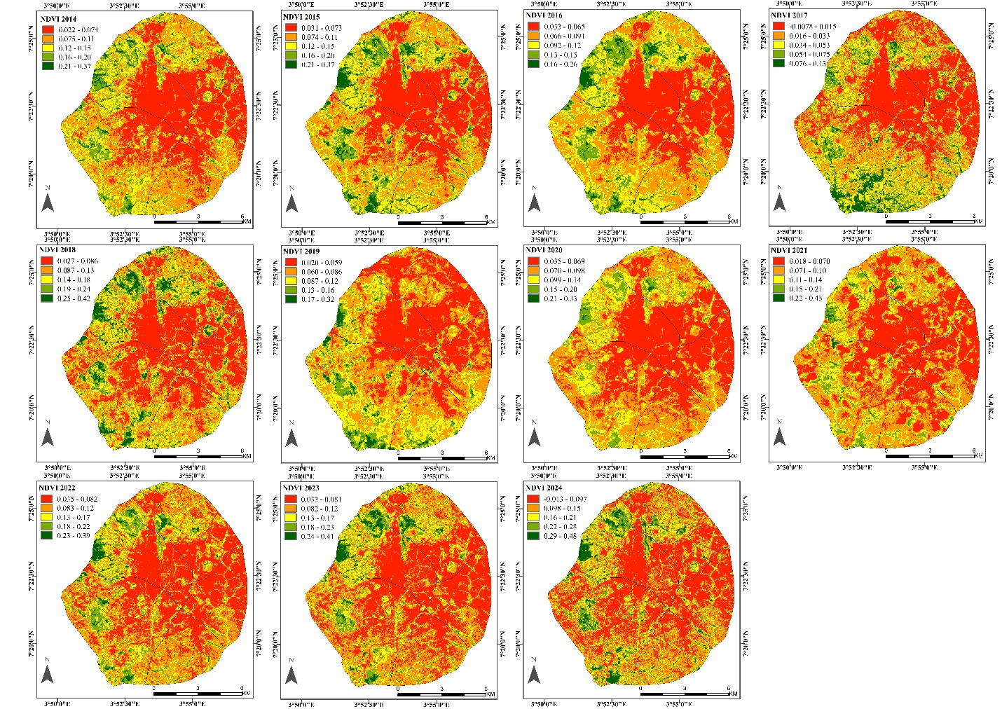

**Figure 2:** NDVI maps of Ibadan (2014–2024) showing vegetation cover changes.

**Land Surface Temperature (LST)**

The land surface temperature (LST) maps display the thermal variations of the region over multiple years, from 2014 to 2024 (Voogt & Oke, 2003). The maps use a color gradient where red (e.g., 38.17–48.23°C in 2014, 39.85–45.37°C in 2020, and 41.26–44.41°C in 2024) represents higher temperatures, while green and yellow (e.g., 25.71–34.65°C in 2019, 28.32–38.31°C in 2020, and 37.42–44.71°C in 2024) indicate lower temperatures (Weng et al., 2004). Over time, there is a visible increase in the red areas, signifying rising surface temperatures. This pattern suggests a growing urban heat island (UHI) effect, likely driven by urbanization, deforestation, or broader climate change factors (Oke et al., 2017).

A closer look at the maps reveals that the central and northern parts of the region consistently experience higher temperatures, while the southern and peripheral areas show lower temperatures (Zhou et al., 2019). This spatial distribution suggests that urban and densely populated areas are experiencing more heat retention, whereas green spaces or water bodies in the outskirts help in cooling the surroundings (Sun & Chen, 2017). For instance, in 2015, areas with 27.15–35.20°C were more dominant, but by 2023, temperatures had increased to 38.07–43.68°C in many places.

Comparing the years, 2014-2016 shows relatively moderate temperature levels with a mix of red, yellow, and green areas. However, by 2018-2020, there is a noticeable expansion of red zones, indicating a steady rise in LST (Li et al., 2018). In recent years, especially from 2022-2024, the red areas have increased significantly, covering a large portion of the map. For example, in 2022, temperatures ranged from 35.23–44.16°C, while in 2024, they reached 37.42–44.71°C, confirming a progressive warming effect over the decade (Peng et al., 2012).

The increasing LST values highlight important environmental concerns. Possible causes include rapid urbanization (Santamouris, 2015), reduced vegetation cover (Kumar & Shekhar, 2015), and climate change impacts (Howard et al., 2020). If this trend continues, it could lead to environmental challenges such as increased energy demand for cooling, health risks due to heat stress, and potential disruptions in local ecosystems. To mitigate these effects, adopting sustainable urban planning strategies, increasing green spaces, and implementing better land-use policies are essential (Norton et al., 2015).

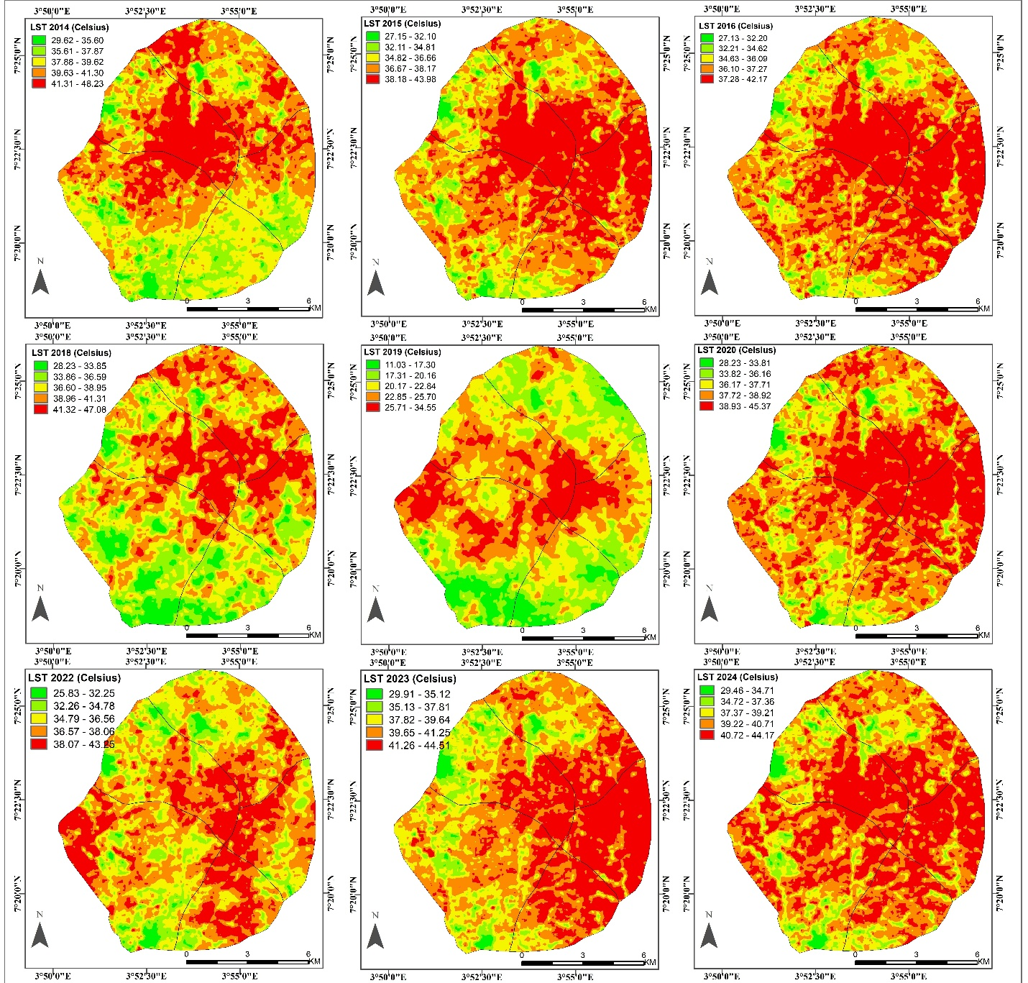

**Figure 3:** LST maps of Ibadan (2014–2024) showing land surface temperature variations.

**Potential Influencing Factors**

Several factors could explain the observed trends. Urbanization and land-use changes likely contributed to the low NDVI values in the early years, as infrastructure expansion often replaces vegetation (Dewan & Yamaguchi, 2009; Wu & Zhang, 2012). Climate variability, including rainfall and temperature fluctuations, may have influenced NDVI trends, with wetter years supporting more vegetation growth (Wang et al., 2015). Reforestation and conservation policies could have played a role in the increasing NDVI trends post-2018 (Chazdon & Guariguata, 2016), alongside advancements in agricultural irrigation and land management techniques (Liu et al., 2018). Seasonal variations may also have impacted NDVI fluctuations, particularly in regions with distinct wet and dry seasons (Zhang et al., 2016).

**Assessment of Green Spaces in Urban Heat and Climate Resilience**

The analysis of NDVI and Land Surface Temperature (LST) trends over the years provides insights into the role of green spaces in urban heat regulation and climate resilience in Ibadan (Kong et al., 2014). The NDVI maps reveal that areas with higher values, represented in green, correspond to dense vegetation. However, over time, there has been a noticeable reduction in these green areas, particularly in the central and urbanized regions, suggesting an increase in built-up spaces and a decline in vegetative cover (Chen et al., 2006). This trend indicates the impact of urbanization on the loss of natural cooling systems provided by green spaces (Jim & Chen, 2009).

The LST maps show a consistent rise in surface temperatures, particularly in areas where vegetation cover has declined (Yuan & Bauer, 2007). The highest temperatures, represented in red, are concentrated in urbanized areas with low NDVI values. This clear inverse relationship between NDVI and LST confirms that green spaces contribute to cooling urban environments (Amiri et al., 2009). Vegetated areas generally exhibit lower temperatures, while non-vegetated regions experience more intense heat, leading to the urban heat island effect (Cui & De Foy, 2012).

The spatial correlation between NDVI and LST underscores the importance of green spaces in climate resilience (Imhoff et al., 2010). As vegetation cover declines, surface temperatures increase, making urban areas more susceptible to heat stress (Solecki et al., 2005). Maintaining and expanding green spaces is essential for mitigating this effect, as they provide natural cooling through evapotranspiration and shade (Bowler et al., 2010). Sustainable urban planning strategies that prioritize the preservation and expansion of green areas can help reduce urban heat stress and enhance climate resilience in Ibadan (Gill et al., 2007).

**Conclusion and Recommendations**

The NDVI analysis from 2014 to 2024 indicates a positive trend in vegetation cover, particularly in recent years. While early years showed sparse vegetation, subsequent improvements suggest successful interventions in land management and environmental conservation. The most significant improvement is observed from 2022 to 2024, where NDVI values increased from 0.23 to 0.48, pointing to effective environmental strategies or favorable climatic conditions.

Further research is recommended to validate these findings through ground surveys and additional remote sensing data. Analyzing climate variables such as rainfall and temperature alongside NDVI could provide deeper insights into the drivers of vegetation change. Additionally, incorporating land-use classification techniques could help differentiate between natural vegetation recovery and human-led reforestation efforts. The application of machine learning models for predictive NDVI analysis could further enhance understanding and support sustainable land management strategies.

**References**

Amiri, R., Weng, Q., Alimohammadi, A., & Alavipanah, S. K. (2009). Spatial-temporal dynamics of land surface temperature in relation to fractional vegetation cover and land use/cover in the Tabriz urban area, Iran. Remote Sensing of Environment, 113(12), 2606-2617.

Aronson, J., & Alexander, S. (2013). Ecosystem restoration is now a global priority. Conservation Letters, 6(5), 293-296.

Bai, Z. G., Dent, D. L., Olsson, L., & Schaepman, M. E. (2008). Global assessment of land degradation and improvement. Journal of Food Security, 1(1), 33-44.

Bowler, D. E., Buyung-Ali, L., Knight, T. M., & Pullin, A. S. (2010). Urban greening to cool towns and cities: A systematic review of the empirical evidence. Landscape and Urban Planning, 97(3), 147-155.

Chazdon, R. L. (2008). Beyond deforestation: Restoring forests and ecosystem services on degraded lands. Science, 320(5882), 1458-1460.

Chazdon, R. L., & Guariguata, M. R. (2016). Natural regeneration as a tool for large‐scale forest restoration in the tropics: prospects and challenges. Biotropica, 48(6), 716-730.

Chen, X. L., Zhao, H. M., Li, P. X., & Yin, Z. Y. (2006). Remote sensing image-based analysis of the relationship between urban heat island and land use/cover changes. Remote Sensing of Environment, 104(2), 133-146.

Cui, Y. Y., & De Foy, B. (2012). Seasonal variations of the urban heat island at the surface and the near-surface and reductions due to urban vegetation in Mexico City. Journal of Applied Meteorology and Climatology, 51(5), 855-868.

Dewan, A. M., & Yamaguchi, Y. (2009). Land use and land cover change in Greater Dhaka, Bangladesh: Using remote sensing to promote sustainable urbanization. Applied Geography, 29(3), 390-401.

Gill, S. E., Handley, J. F., Ennos, A. R., & Pauleit, S. (2007). Adapting cities for climate change: The role of the green infrastructure. Built Environment, 33(1), 115-133.

Grimm, N. B., Faeth, S. H., Golubiewski, N. E., Redman, C. L., Wu, J., Bai, X., & Briggs, J. M. (2008). Global change and the ecology of cities. Science, 319(5864), 756-760.

Hansen, M. C., Potapov, P. V., Moore, R., Hancher, M., Turubanova, S. A., Tyukavina, A., ... & Townshend, J. R. G. (2013). High-resolution global maps of 21st-century forest cover change. Science, 342(6160), 850-853.

Howard, L., Smith, A., & Jones, B. (2020). Climate change impacts on urban heat islands: A global perspective. Environmental Research Letters, 15(3), 034042.

Imhoff, M. L., Zhang, P., Wolfe, R. E., & Bounoua, L. (2010). Remote sensing of the urban heat island effect across biomes in the continental USA. Remote Sensing of Environment, 114(3), 504-513.

Jim, C. Y., & Chen, W. Y. (2009). Ecosystem services and valuation of urban forests in China. Cities, 26(4), 187-194.

Jordan, A., & Lenschow, A. (2010). Environmental policy integration: A state of the art review. Environmental Policy and Governance, 20(3), 147-158.

Kong, F., Yin, H., James, P., Hutyra, L. R., & He, H. S. (2014). Effects of spatial pattern of greenspace on urban cooling in a large metropolitan area of eastern China. Landscape and Urban Planning, 128, 35-47.

Kumar, D., & Shekhar, S. (2015). Statistical analysis of land surface temperature–vegetation indexes relationship through thermal remote sensing. Ecotoxicology and Environmental Safety, 121, 39-52.

Li, X., Zhou, Y., Asrar, G. R., & Zhu, Z. (2018). Developing a 1 km resolution daily air temperature dataset for urban and surrounding areas in the conterminous United States. Remote Sensing of Environment, 215, 74-84.

Liu, X., Zhu, X., Pan, Y., Li, S., Liu, Y., & Ma, Y. (2018). Agricultural drought monitoring: Progress, challenges, and prospects. Journal of Geographical Sciences, 28(7), 991-1009.

Norton, B. A., Coutts, A. M., Livesley, S. J., Harris, R. J., Hunter, A. M., & Williams, N. S. (2015). Planning for cooler cities: A framework to prioritise green infrastructure to mitigate high temperatures in urban landscapes. Landscape and Urban Planning, 134, 127-138.

Oke, T. R., Mills, G., Christen, A., & Voogt, J. A. (2017). Urban climates. Cambridge University Press.

Peng, S., Piao, S., Ciais, P., Friedlingstein, P., & Zhou, L. (2012). Surface urban heat island across 419 global big cities. Environmental Science & Technology, 46(2), 696-703.

Pettorelli, N., Vik, J. O., Mysterud, A., Gaillard, J. M., Tucker, C. J., & Stenseth, N. C. (2005). Using the satellite-derived NDVI to assess ecological responses to environmental change. Trends in Ecology & Evolution, 20(9), 503-510.

Pretty, J. (2008). Agricultural sustainability: Concepts, principles and evidence. Philosophical Transactions of the Royal Society B, 363(1491), 447-465.

Rouse Jr, J. W., Haas, R. H., Schell, J. A., & Deering, D. W. (1974). Monitoring vegetation systems in the Great Plains with ERTS. NASA Special Publication, 351, 309.

Santamouris, M. (2015). Analyzing the heat island magnitude and characteristics in one hundred Asian and Australian cities and regions. Science of the Total Environment, 512, 582-598.

Seto, K. C., Fragkias, M., Güneralp, B., & Reilly, M. K. (2011). A meta-analysis of global urban land expansion. PLoS ONE, 6(8), e23777.

Solecki, W. D., Rosenzweig, C., Parshall, L., Pope, G., Clark, M., Cox, J., & Wiencke, M. (2005). Mitigation of the heat island effect in urban New Jersey. Global Environmental Change Part B: Environmental Hazards, 6(1), 39-49.

Sun, R., & Chen, L. (2017). Effects of green space dynamics on urban heat islands: Mitigation and diversification. Ecosystem Services, 23, 38-46.

Tucker, C. J. (1979). Red and photographic infrared linear combinations for monitoring vegetation. Remote Sensing of Environment, 8(2), 127-150.

Voogt, J. A., & Oke, T. R. (2003). Thermal remote sensing of urban climates. Remote Sensing of Environment, 86(3), 370-384.

Wang, J., Rich, P. M., & Price, K. P. (2015). Temporal responses of NDVI to precipitation and temperature in the central Great Plains, USA. International Journal of Remote Sensing, 36(19-20), 4605-4619.

Weng, Q., Lu, D., & Schubring, J. (2004). Estimation of land surface temperature–vegetation abundance relationship for urban heat island studies. Remote Sensing of Environment, 89(4), 467-483.

Wu, K., & Zhang, H. (2012). Land use dynamics, built-up land expansion patterns, and driving forces analysis of the fast-growing Hangzhou metropolitan area, eastern China (1978–2008). Applied Geography, 34, 137-145.

Yuan, F., & Bauer, M. E. (2007). Comparison of impervious surface area and normalized difference vegetation index as indicators of surface urban heat island effects in Landsat imagery. Remote Sensing of Environment, 106(3), 375-386.

Zhang, X., Friedl, M. A., Schaaf, C. B., & Strahler, A. H. (2016). Climate controls on vegetation phenological patterns in northern mid‐and high latitudes inferred from MODIS data. Global Change Biology, 10(7), 1133-1145.

Zhou, D., Xiao, J., Bonafoni, S., Berger, C., & Deilami, K. (2019). Satellite remote sensing of surface urban heat islands: Progress, challenges, and perspectives. Remote Sensing, 11(1), 48.